Name: …………………………………………………………….… Index No. ……………….. Signature:….……

P530/1
Biology
(Theory)
Paper 1
June/July 2018
2 ½Hours

ACEITEKA JOINT MOCK EXAMINATIONS 2018
Uganda Advanced Certificate of Education
BIOLOGY (THEORY)
Paper 1
TIME: 2 hours 30 minutes
Instructions to Candidates:
Answer all questions in both sections A and B.
Answers to Section A should be written in the boxes provided
Answers to Section B should be written in spaces provided.
No additional answer sheets should be attached to this booklet.
For Examiner’s use only
Section | Mark | Examiner’s signature and No.
A: 1-40
B: 41
42
43
44
45
46
Total

Section A: (40 marks)
1. The term countercurrent multiplier in the kidney means that
A. the fluid in and around the loop of Henle becomes saltier as it goes down the loop, is saltiest at the hairpin bend and becomes less salty as it goes up the ascending limb
B. the fluid in and around the loop of Henle becomes saltier as it goes up the loop, is saltiest at the hairpin bend and becomes less salty as it goes down the descending limb
C. the fluid in and around the loop of Henle becomes less salty as it goes down the loop, is least salty at the hairpin bend and becomes saltier as it goes up the ascending limb
D. the fluid in and around the loop of Henle becomes less salty as it goes up the loop, is least salty at the hairpin bend and becomes saltier as it goes down the descending limb

2. During amniocentesis, chromosomal abnormalities of the developing foetus can be detected by taking the sample of the;
A. foetal blood
B. mother’s blood
C. fluid surrounding the foetus
D. fluid from umbilical cord

3. Which one of the following hormones is antagonistic to parathormone?
A. Calcitonin
B. Aldosterone
C. Thyroxine
D. Adrenaline

4. Punctuated equilibrium refers to
A. Gradual transition over many millions of years from one form to another
B. Short periods of rapid evolution in equilibrium with long periods of constancy
C. Long periods of rapid evolution in equilibrium with short periods of no change
D. Short periods of rapid evolution in equilibrium with short periods of no change

5. Which one of the following cell organelles will be isolated last by differential centrifugation?
A. Mitochondrion
B. Nucleus
C. Endoplasmic reticulum
D. Chloroplast

6. Which one of the following organisms has two separate hearts?
A. Squid
B. Frog
C. Octopus
D. Both A and C

7. The form in which insect’s tissues produce nitrogenous waste is
A. Potassium urate
B. Potassium hydrogencarbonate
C. Uric acid
D. Trimethylamine oxide

8. Cortisol hormone from adrenal cortex is released to combat each of the following except
A. Hemolytic disease of the new-born
B. Inflammation
C. Allergy
D. Effects of shock

9. A distinguishing feature of fast twitch skeletal muscle fibres is
A. Few mitochondria
B. Low glycogen content
C. Aerobic respiration
D. Many mitochondria

10. In the alternation of generation life cycle;
A. Sporophyte generation is always dominant
B. Gametophyte generation produces the spores
C. Spores develop into the sporophyte generation
D. Gametophyte generation is haploid

11. A desert mammal’s lower lethal temperature is higher than that of a mammal living in cold regions because a desert mammal has
A. poor insulation mechanisms
B. small extremities
C. thick fur
D. a small surface area: volume ratio

12. Blood worms and liver flukes belong to phylum
A. Nematoda
B. Cestoda
C. Annelida
D. Platyhelminthes

13. In mice, yellow fur (Y) is dominant over grey fur (y). When two mice were mated, the offspring were in the ratio of 2 yellow to 1 grey.
From the results, which of the following were the likely genotypes of the parents?
A. Both were homozygous dominant.
B. One was heterozygous and the other homozygous dominant.
C. Both were heterozygous.
D. Both were homozygous recessive.

14. Which one is the odd man out?
A. Stratification
B. Vernalisation
C. Scarification
D. After-ripening period

15. The following are true of epithelial tissue except…
A. In a simple epithelium some of the cells touch the basement membrane
B. In a compound epithelium only the lower layer of cells touch the basement membrane
C. simple epithelium has one layer of cells
D. compound epithelium has more than one layer of cells

16. Hormones are present in minute concentrations yet they have large effects on target cells and on the individual as a whole. This is possible because a single hormone molecule can
A. bind irreversibly to its receptor
B. bind to many receptors at once
C. initiate transcription of DNA by binding to cell surface receptors
D. activate many intracellular enzymes

17. The layer of cells in nocturnal mammals that reflects light in the eye back to the eye ball giving it a glowing appearance is
A. Choroid
B. Tapetum
C. Cornea
D. Fovea

18. The type of learning that involves immediate understanding and responding is
A. Imprinting
B. Associative learning
C. Insight learning
D. Habituation

19. Why are action potentials usually conducted in only one direction along an axon?
A. The nodes of Ranvier can conduct potentials in only one direction.
B. The brief refractory period prevents reopening of voltage-gated sodium ion channels
C. Ions can flow along the axon in only one direction.
D. Voltage-gated channels for both sodium and potassium ions open in only one direction.

20. Warfarin is a substance that inhibits blood clotting. Rats which eat warfarin are killed due to internal bleeding, in case they inherit this recessive condition in homozygous state. If in a population of wild rats 51% were resistant to warfin, using Hardy-Weinberg equation what percentage of the rats were heterozygous to warfin resistance?
A. 42%
B. 49%
C. 70%
D. 9%
21. A piece of DNA was analysed and 15% of its nucleotides were found to contain guanine. What percentage of its nucleotides would you expect to contain adenine?
A. 15%
B. 35%
C. 85%
D. 70%

22. Which one of the following shunts fetal blood from the pulmonary artery into the aorta?
A. Ductus arteriosus
B. Foramen ovale
C. Ductus venosus
D. Sinus venosus

23. Cell walls of prokaryotes are made of a material called
A. Hyaluronic acid
B. Suberin
C. Murein
D. Chitin

24. The principle producers in marine ecosystems are the
A. Phytoplankton
B. Zooplankton
C. Green algae
D. Detritivores

25. The role of Calcium ions in muscle contraction is that binds to
A. tropomyosin, enabling troponin to move and reveal binding sites for cross bridges
B. troponin, enabling tropomyosin to move and reveal binding sites for cross bridges.
C. tropomyosin, enabling troponin to release ATP
D. troponin, enabling tropomyosin to release ATP

26. Which of the following genetic diseases is caused by a dominant allele?
A. Huntington’s disease
B. albinism
C. sickle cell anaemia
D. Cystic fibrosis

27. Pepsin enzyme in the human alimentary canal is secreted by
A. Chief cells
B. Oxyntic cells
C. Goblet cells
D. Mucous cells

28. Which one of the following is not an advantage of panting in organisms as opposed to sweating?
A. Oxygenation of blood
B. Much water is lost
C. Less salts are lost
D. Results in drop in acidity of blood

29. The figure below show the structure of a common organic chemical of life.
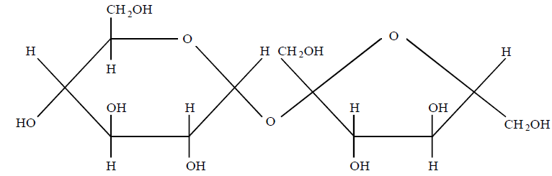

Which one of the following is not a property of the molecule?
A. It is soluble in water
B. It can be hydrolysed by a mineral acid
C. is a reducing sugar
D. It is crystalline

30. Which one of the following is an advantage of C₃ plants over C₄ and CAM plants?
A. Dark stage of photosynthesis occurs in one cell type
B. Dark stage of photosynthesis consumes less energy
C. Dark stage of photosynthesis occurs all day and night
D. The plants occupy a wider range of habitats

31. The graph below shows the oxygen dissociation curves for different respiratory pigments in man.
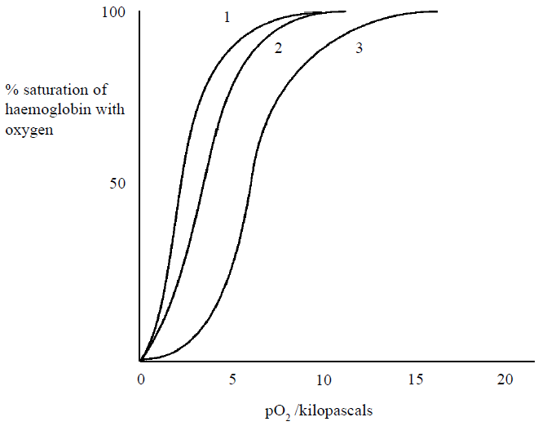

The identity of the curves for fetal haemoglobin, normal haemoglobin and myoglobin respectively is
A. 1, 2, 3
B. 2, 3, 1
C. 3, 2, 1
D. 2, 1, 3
32. Which one of the following undergoes isometric growth?
A. Amphibians
B. Birds
C. Mammals
D. Fish

33. The cross carried out to find the genotype of an organism is known as
A. Back cross
B. Breeding true
C. Test cross
D. Reciprocal cross

34. How many water molecules are produced when 60 fatty acid molecules are used to form phospholipids?
A. 15
B. 30
C. 60
D. 90

35. The diagram represents a metabolic pathway controlled by enzymes.
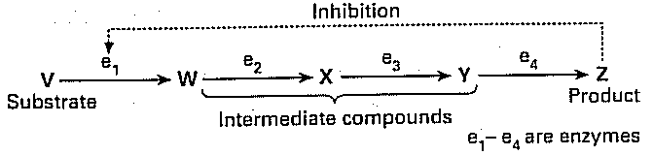

Which one of the following is not in line with how production of Z is regulated?
A. Feedback inhibition
B. Allosteric inhibition
C. Positive feedback
D. Negative feedback

36. The phylogenetic species concept refers a species as a group of organisms that;
A. can interbreed and produce fertile offspring
B. show close similarity in genetic karyotype
C. inhabit the same ecological niche
D. share common ancestry

37. Which one of the following is not associated with the adjacent guard cells’ response at night in a leaf?
A. Raise in concentration of carbonic acid in the intercellular spaces
B. Drop in hydrogen ion concentration
C. Fall in water potential of guard cells
D. Conversion of sugar to starch

38. The assembly point through which raw materials for secretion are funnelled before being shed from the cell is
A. Golgi body
B. Endoplasmic reticulum
C. Lysosome
D. Peroxisome

39. Which one of the following amino acids is abundant in human hair?
A. Methionine
B. Cysteine
C. Tryptophan
D. Valine

40. The following Chordates have notochord replaced by backbone during development except
A. Shark
B. Whale
C. Sea squirt
D. Toad

SECTION B: (60 marks)
Write answers in the spaces provided.
41. In an investigation of aerobic respiration, isolated mitochondria were added to a prepared medium containing succinate and inorganic phosphate. The medium was saturated with oxygen. Equal amounts of ADP were added at one-minute intervals, and measurements were taken of the oxygen concentration in the medium. The graph shows the results.
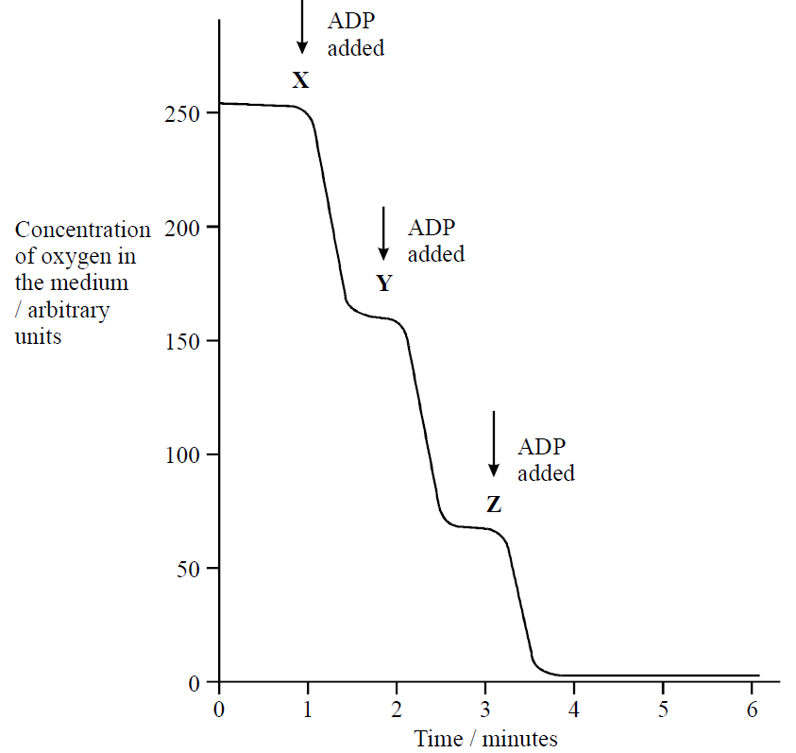

(a) Explain why the oxygen concentration in the medium decreased after adding ADP at X. (02 marks)
………………………………………………………………………………………………………………………………………………………………..……………………………………..…………………………………………………………………………………………………………………………………………………………………………………………………………………………………………………………………………..
(b) Explain why the fall in oxygen concentration, following the addition of ADP, was less at Z than at Y. (02 marks)

……………………………………………………………………………………………………………………………………………………………………………………………………………………………………………………………………………………………………………………………………………………………………………………………………………………………………………………………………………………………………………………………………………………………………………………………………………………………………………………
c) A similar experiment was carried out with glucose instead of succinate. Again, the medium was saturated with oxygen, and excess ADP was added. Suggest and explain the observation that was made. (04 marks)

……………………………………………………………………………………………………………………………………………………………………………………………………………………………………………………………………………………………………………………………………………………………………………………………………………………………………………………………………………………………………………………………………………………………………………………………………………………………………………………………………………………………………………………………………………………………………………………………………………………………………………………………………………………………………………………………………………………………………………..
d) Outline four uses of ATP molecule in a liver cell. (02 marks)

…………………………………………………………………………………………………………………………………………………………………………………………………………………………………………………………………………………………………………………………………………………………………………………………………………………………………………………………………………………………………………………………………………………………………………………………………………………………………………………..

42.(a) Define the term oceanic island? (01 mark)

..................................................................................................................................................................................................................................................................................................................................(b) Suggest how Darwin’s finch species on the Galapagos islands could have evolved. (05 marks)

.........................................................................................................................................................................................................................................................................................................................................................................................................................................................................................................................................................................................................................................................................................................................................................................................................................................................................................................................................................................................................................................................................................................................................................................................................................................................................................................................................................................................................................................................................................................(c) State ways how the present-day finches of the same species on the Galapagos islands recognize each other. (02 marks)
...................................................................................................................................................................................................................................................................................................................................................................................................................................................................................................
(d) State two observations made by Charles Darwin that eventually led to his theory of Natural Selection. (02 marks)
........................................................................................................................................................................................................................................................................................................................................................................................................................................................................................................................................................................................................................................

43. Seeds were stored at 5ºC, 15ºC and 22ºC for eight months. Samples of seed were germinated every month and the percentages of seeds that germinated were recorded. The graph below shows the results of this investigation.
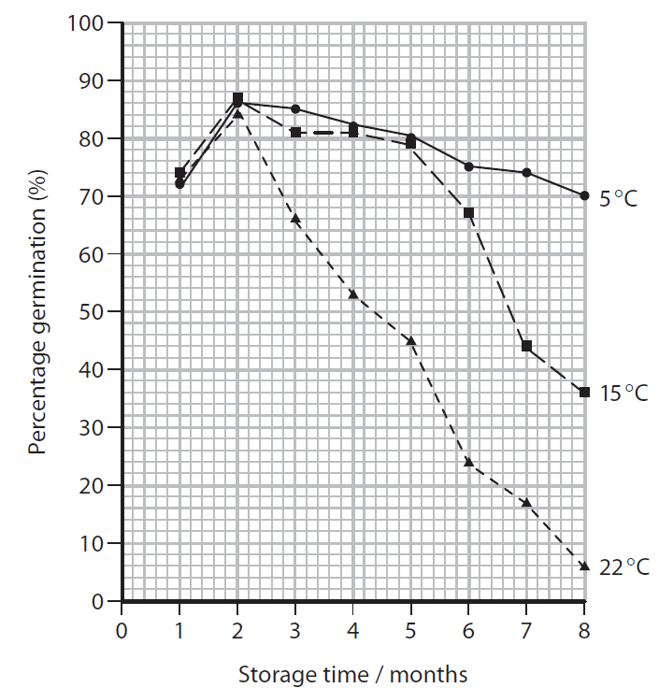

(a) Using the information in the graph, describe the effect of storage time and temperature on percentage germination of seeds. (03 marks)
.................................................................................................................................................................................................................................................................................................................................................................................................................................................................................................................................................................................................................................................................................................................................................................................................
(b) Explain the effect of storage temperature on the percentage germination of the stored seeds. (03 marks)
.................................................................................................................................................................................................................................................................................................................................................................................................................................................................................................................................................................................................................................................................................................................................................................................................
(c) Explain why seeds are dried before they are stored in a seed bank. (02 marks)
..............................................................................................................................................................................................................................................................................................................................................................................................................................................................................

(d) Suggest two other practical ways of preventing species extinction apart from seed banks. (02 marks)
..............................................................................................................................................................................................................................................................................................................................................................................................................................................................................
44. (a) (i) Define the term attenuated microorganism? (01 mark)
....................................................................................................................................................................................................................................................................................................................
ii) Vaccines protect against disease by stimulating the production of memory cells. Describe how memory cells are produced and protect the body from disease. (05 marks)
...............................................................................................................................................................................................................................................................................................................................................................................................................................................................................................................................................................................................................................................................................................................................................................................................................................................................................................................................................................................................................................................................................................................................................................................................................................................................................
(b) The table shows statements, which may be related to active immunity or passive immunity. Complete the table by placing a tick in the box if the statement is true or a cross in the box if the statement is false. (04 marks)
Statement | Active immunity | Passive immunity
Antibodies produced if the body is re-infected
by the same pathogen.
Antibodies developed in horse injected into human.
Antibodies received in breast milk.
Attenuated microorganisms used in the vaccine.

45. The graph shows the changes in concentration of the hormones responsible for controlling the menstrual cycle during the first 15 days in the body of a woman.
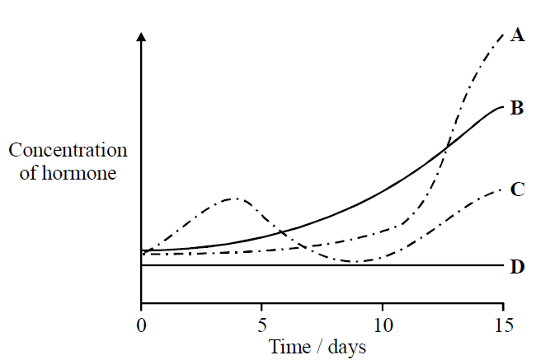
(a) What does each curve represent? (02 marks)
…………………………………………………………………………………………………………………………………………………………………………………………………………………………………………………………………………………………………………………………………………………………………………………………………………………………………………………………………………………………………………………………………………………………………………………………………………………... (b) Explain how the release of hormone C is controlled by negative feedback in the body of the woman. (04 marks)
………………………………………………………………………………………………………………………………………………………………………………………………………………………………………………………………………………………………………………………............……………………………………………………………………………………………………………………………………………………………………………………………………………………………………………………………………………………………………………………………………………………………………………………………………………………………………………………………………………………………………………………………………………………………………………………………

(c) Explain what happens to the concentration of hormone D over the remainder of this menstrual cycle. (02 marks)
……………………………………………………………………………………………………………………………………………………………………………………………………………………………………………………………………………………………………………………................………………………………………………………………………………………………………………………………………………………………………………………………………………………………………………………………………………
d) Explain how hormone B may act as a contraceptive. (02 marks)
……………………………………………………………………………………………………………………………………………………………………………………………………………………………………………………………………………………………………………………...............…………………………………………………………………………………………………………………………………………………………………………………………………………………………………………………………………………………
46. (a) Describe the structure of the prothallus (gametophyte) in the life cycle of a fern. (04 marks)
...........………………………………………………………………………………………………………………………………………………………………………………………………………..........………………………………………………………………………………………………………………………………………………………………………………………………………...........…………………………………………………………………………………………………………………………………………………..………………………………………………………………………………………………………………………………………………………………………………………………………………………………………………………………………………………………………………………..
(b) Give two reasons why the fern cannot survive entirely on land in its life cycle. (02 marks)
...........……………………………………………………………………………………………………………………………………………………………………………………………………………………………………………………………………………………………………………………………… ………............………………………………………………………………………………………………
(c) State four adaptations of lichens as pioneer community in ecological succession. (04 marks)
...........………………………………………………………………………………………………………………………………………………………………………………………………………...........…………………………………………………………………………………………………………………………………………………………………………………………………………………………………………………………………………………………………………………………………………………………………………………………...………………………………………………………………………………………………………………………………………………………………………………………………………………………………………………………………………………………………………………………………………………………………………………………………………………………………………………………..
END

